Data Analytics with Power BI (INT374)
PROJECT REPORT
(Project Semester August-December 2025)

India Telecom Performance Dashboard

Submitted by:
Arjun Maurya
Registration No: 12318080
Program and Section: B. Tech CSE
Course Code: INT 374

Under the Guidance of
Aashima Bansal (28968) Assistant Professor
Discipline of CSE
Lovely School of Computer Science and Engineering
Lovely Professional University, Phagwara

DECLARATION

I, Arjun Maurya, student of B.Tech under the School of Computer Science and Engineering, Lovely Professional University, Punjab, hereby declare that all the information furnished in this project report is based on my own intensive work and is genuine.

Date: 15/12/2025 Signature:
Registration No: 12318080 Name: Arjun Maurya

CERTIFICATE

This is to certify that Arjun Maurya, bearing Registration No. 12318080 has successfully completed the INT374 project titled “Telecom Call Quality Overview” under my guidance and supervision. To the best of my knowledge, the present work is the result of their original effort and development.

Signature and Name of the Supervisor
Designation
School of Computer Science and Engineering
Lovely Professional University, Phagwara, Punjab
Date:

ACKNOWLEDGEMENT

I would like to express my sincere gratitude to my faculty coordinator, Aashima Bansal (28968), for her constant encouragement, support, and insightful feedback throughout the duration of this project. I would also like to extend my thanks to Lovely Professional University for providing the infrastructure, access to academic databases, and an intellectually stimulating environment that made this work possible. My heartfelt appreciation also goes to my peers for their valuable suggestions, and to my family for their unwavering motivation and emotional support.

TABLE OF CONTENTS

S. No. | HEADINGS | PAGE NO.
1. | Introduction | 6
2. | Source of Dataset | 7
3. | Dataset Characteristics | 9
4. | Objectives | 12
5. | Excel Dashboard Design | 13
6. | Dashboard Visualizations and Interpretation | 15
7. | Data Analysis & Insights | 21
8. | Observations & Discussions | 12
9. | Conclusion | 23
10. | Future Scope | 24
11. | References | 25
12. | Important Links | 26

INTRODUCTION

1. Introduction
In today’s digitally connected world, the quality and reliability of telecommunication services play a crucial role in economic growth, social connectivity, and everyday communication. With the rapid expansion of mobile networks across India, users expect seamless call connectivity, minimal call drops, and satisfactory voice quality irrespective of location, network technology, or service provider. However, challenges such as call drops, poor voice clarity, and inconsistent service quality continue to affect user experience.
The Indian telecom sector consists of multiple network operators operating across diverse geographical regions and varying technological infrastructures such as 2G, 3G, and 4G. Factors including user environment (indoor, outdoor, travelling), network type, operator performance, and regional infrastructure significantly influence overall call quality. Analyzing these factors in isolation is insufficient; instead, an integrated, data-driven approach is required to uncover meaningful insights and performance patterns.
This project focuses on analyzing telecom call quality data collected across different states of India over multiple years. The analysis aims to evaluate key performance indicators such as call drop rates, poor voice quality, and satisfactory call experiences. By leveraging data visualization techniques and interactive dashboards, the project transforms raw telecom data into actionable insights that help identify trends, problem areas, and comparative performance among operators and regions.
A comprehensive dashboard has been developed to provide a nationwide overview as well as deeper insights into state-wise and operator-wise performance. The dashboard enables stakeholders to explore temporal trends, understand the impact of network technologies, assess user environment effects, and identify the worst-performing network combinations using a custom quality scoring approach.
Overall, this report presents a structured analysis of telecom call quality in India, combining statistical measures, visual analytics, and interactive filtering to support data-driven decision-making and performance evaluation in the telecom domain.

SOURCE OF DATASET

The dataset used for this project has been sourced from data.gov.in, the official Open Government Data (OGD) platform of the Government of India. The specific dataset utilized for analysis is titled “Voice Call Quality & Customer Experience till Last Month”. This dataset is published to promote transparency, data-driven decision-making, and public research in the telecommunications sector.
Dataset Source URL:
https://www.data.gov.in/resource/voice-call-quality-customer-experience-till-last-month
The dataset provides comprehensive information related to voice call quality and customer experience across India. It captures real-world user-reported network performance data over multiple years, making it suitable for longitudinal and comparative analysis. The data covers various dimensions of mobile network usage and quality across different states, operators, technologies, and user environments.
Dataset Contents
The dataset contains multiple attributes that collectively describe the quality of voice call experiences. Key information included in the dataset is as follows:
- Geographical Information:
  - State name
  - Latitude and longitude coordinates
This allow state-wise and location-based analysis of network performance across India.
- Temporal Information:
  - Year
  - Month
  - Year-Month combination
These fields enable time-series analysis to study trends, patterns, and changes in call quality over time.
- Operator Details:
  - Mobile network operators such as Jio, Airtel, BSNL, and VI
This makes it possible to perform operator-wise comparisons and identify performance differences among service providers.
- Network Technology:
  - Network type including 2G, 3G, and 4G
This helps analyze the impact of different mobile technologies on call quality and customer satisfaction.
- User Environment:
  - Indoor
  - Outdoor
  - Travelling
These categories provide insights into how user surroundings affect call quality and network reliability.
- Call Quality Indicators:
  - Call dropped
  - Poor voice quality
  - Satisfactory calls
These indicators form the basis for calculating performance metrics such as call drop rate, poor voice percentage, and satisfaction rate.
The dataset is structured in a tabular format and is updated periodically, ensuring relevance and consistency. Its rich combination of spatial, temporal, and technical attributes enables in-depth analysis and visualization of telecom call quality across India.
By leveraging this dataset, the project effectively analyzes nationwide telecom performance, identifies critical problem areas, compares operators, and evaluates trends in network quality over time.

DATASET CHARACTERISTICS

This section describes the structure, nature, and key properties of the dataset used for the analysis.
3.1 Nature of the Dataset
The dataset is structured and tabular in nature, making it suitable for analysis using spreadsheet tools (Excel) and business intelligence platforms (Power BI). Each row represents an individual record of user-reported voice call experience, while each column captures a specific attribute related to network quality, location, time, or usage conditions.
The dataset combines categorical, numerical, and temporal data, enabling both descriptive and analytical exploration.
3.2 Time Coverage
- The dataset spans multiple years, covering the period from 2017 to 2024.
- Data is recorded at a monthly level, allowing both month-wise and year-wise trend analysis.
- This long-time horizon makes the dataset suitable for identifying patterns, improvements, and degradations in call quality over time.
3.3 Geographical Coverage
- The dataset covers all major Indian states and union territories.
- Location information is provided through:
  - State names
  - Latitude and longitude values
- This enables state-wise comparisons and geographical visualizations such as maps to identify regional disparities in call quality.
3.4 Key Attributes and Variables
The dataset contains the following important types of variables:
a) Categorical Variables
- State name
- Cleaned state name (standardized format)
- Mobile network operator (Jio, Airtel, BSNL, VI)
- Network type (2G, 3G, 4G)
- User environment (Indoor, Outdoor, Travelling)
- Call quality category (Call Dropped, Poor Voice Quality, Satisfactory)
These variables are useful for grouping, filtering, and comparative analysis.
b) Numerical Variables
- Count of call drops
- Count of poor voice quality calls
- Count of satisfactory calls
- Total issues
- Calculated performance metrics such as:
  - % Call Drops
  - % Poor Voice Quality
  - % Satisfactory
These measures form the basis for KPIs and visual analytics.
c) Temporal Variables
- Year
- Month
- Year–Month
These variables support time-series analysis and trend visualization.
3.5 Derived and Calculated Metrics
To enhance analytical depth, several derived metrics were calculated from the raw data, including:
- Call drop percentage
- Poor voice quality percentage
- Satisfaction percentage
- Quality score (used for ranking worst network quality combinations)
These calculated fields allow meaningful comparisons across states, operators, technologies, and time periods.
3.6 Data Quality and Preprocessing
- The dataset required data cleaning and standardization, particularly for:
  - State names
  - Operator names
- Multiple naming variations were consolidated into standardized fields (e.g., Clean_State and Clean_Operator).
- No personal or sensitive user information is present, ensuring ethical and safe usage of the data.
3.7 Suitability for Analysis
Due to its:
- Nationwide coverage
- Multi-year timeline
- Inclusion of operator, technology, and environment factors
the dataset is highly suitable for:
- Dashboard creation
- Comparative analysis
- Trend analysis
- Decision-support insights related to telecom network performance

Objectives
The primary objective of this project is to analyze and visualize telecom voice call quality across India using data-driven techniques and interactive dashboards. The study aims to identify patterns, trends, and problem areas related to call drops, poor voice quality, and customer satisfaction.

The specific objectives of the study are as follows:
- To visualize the geographical distribution of call quality issues across India.
This objective focuses on using latitude and longitude data to identify regional problem areas and state-wise variations in call quality, helping to understand where network issues are more prevalent.
- To analyze monthly and yearly trends in call quality and network reliability.
By examining changes over time, the study aims to track improvements or degradation in call drops, voice clarity, and customer satisfaction, thereby revealing long-term performance trends in the telecom sector.
- To evaluate the performance of different network technologies (2G, 3G, and 4G).
This objective assesses how various generations of mobile network technology impact voice call quality and reliability, highlighting the role of technology evolution in improving user experience.
- To examine the effect of user environment on call quality.
The study analyzes how call performance varies across indoor, outdoor, and travelling environments, providing insights into environmental factors that influence call drops and poor voice quality.
- To compare telecom service quality across different states.
This objective aims to identify states with consistently poor or strong performance, enabling regional comparison and highlighting areas that require infrastructure improvement.
- To compare call quality and customer satisfaction among different telecom operators.
By analyzing operator-wise performance across network types and user conditions, the study seeks to highlight differences in service quality among major telecom providers such as Jio, Airtel, VI, and BSNL.

Overall, these objectives guide the analytical approach of the project and ensure that the dashboard provides meaningful insights into telecom network performance, customer experience, and service reliability across India.

Dashboard Design & Visualization Approach

The dashboard for this project was designed with the objective of transforming complex telecom call quality data into an intuitive, interactive, and insight-driven visual analytics tool. Emphasis was placed on clarity, usability, and storytelling so that users can easily explore patterns, trends, and problem areas related to voice call quality across India.
The overall dashboard design follows a two-page structure to separate high-level insights from detailed analysis. The first dashboard page provides a national-level overview, presenting key performance indicators (KPIs) and summary visuals that quickly convey the overall state of telecom call quality. The second dashboard page focuses on deeper analytical insights, enabling users to drill down into operator-wise, technology-wise, and time-based performance.
A dark-themed layout was adopted to enhance visual contrast and improve readability during presentations. High-contrast colors were carefully selected to distinguish between good and poor performance, with consistent color usage applied across all visuals. This design choice ensures visual consistency and reduces cognitive load for the user.
To represent spatial patterns, map-based visualizations were used to display the geographical distribution of call quality issues across Indian states. These visuals help identify regional hotspots where call drops and poor voice quality are more prominent. Bar charts and stacked charts were employed to compare states, operators, network types, and user environments, as they provide clear comparative insights.
Line charts were used extensively to analyze time-based trends, such as yearly changes in call drops and customer satisfaction. These visuals effectively communicate whether network performance is improving or deteriorating over time and allow easy comparison between telecom operators.
A leaderboard-style table was incorporated to highlight the worst-performing state–operator combinations using a custom quality score. This approach enables quick identification of critical problem areas and supports focused analysis on regions and operators requiring attention.
Interactivity was a key design consideration. Multiple slicers were implemented to allow users to filter data dynamically based on year, operator, network type, and user environment. These slicers enable users to customize the analysis according to specific interests and enhance exploratory data analysis without overwhelming the interface.
Overall, the dashboard design and visualization approach prioritize simplicity, consistency, and analytical depth. By combining geographical, temporal, and categorical visualizations with interactive controls, the dashboard effectively communicates complex telecom performance data in a user-friendly and actionable manner.
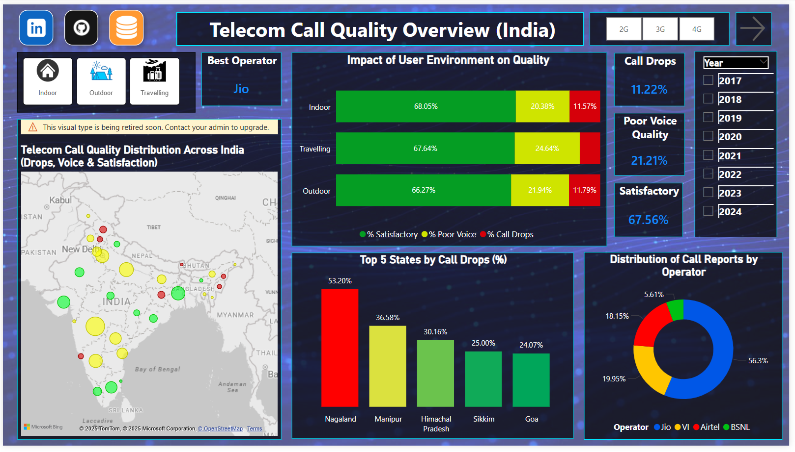
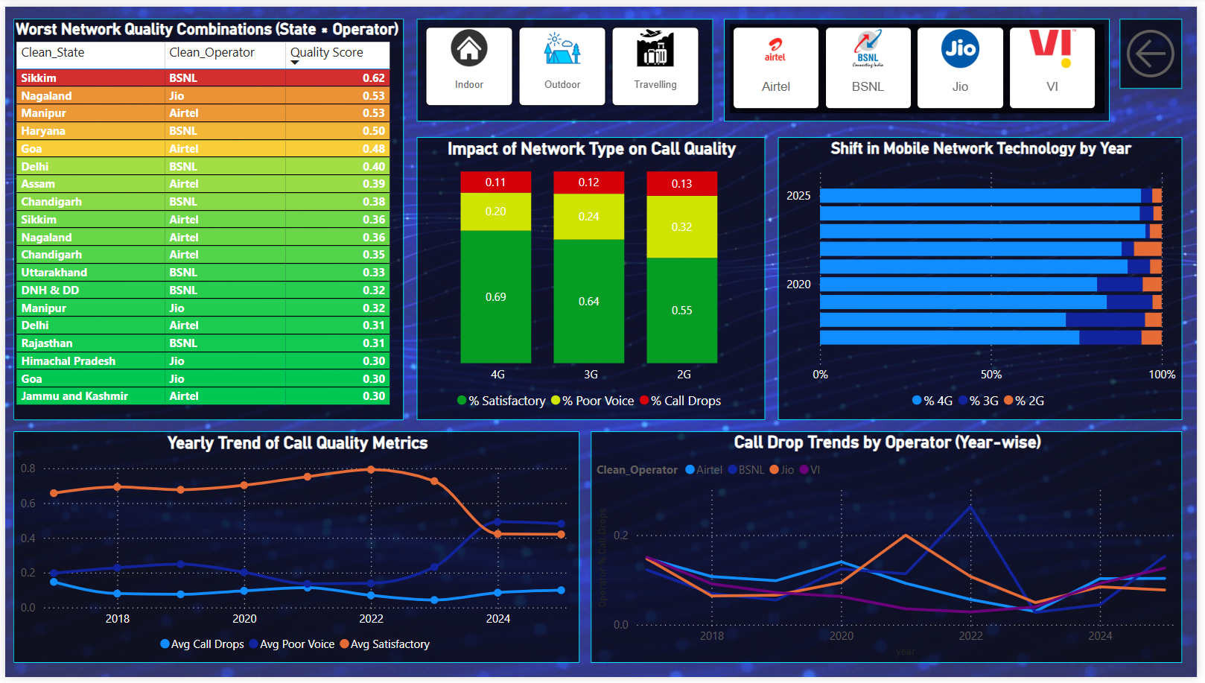

Dashboard Visualizations and Interpretation

This section presents the key visualizations included in the Power BI dashboard along with a brief explanation of the insights derived from each visual. Screenshots of the visuals are provided to support interpretation and understanding.
1. Geographical Distribution of Call Quality Issues
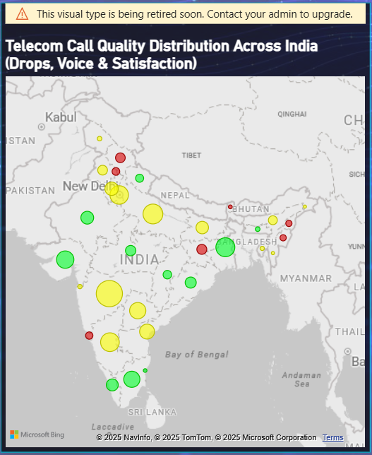
This map visual displays the geographical distribution of call quality issues across Indian states using latitude and longitude data. The intensity of the color represents the severity of call quality problems such as call drops and poor voice quality. States with higher issue concentration are visually highlighted, making it easier to identify regional problem areas where telecom infrastructure may require improvement.
2. Key Performance Indicator (KPI) Cards
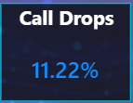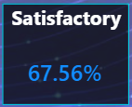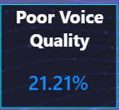
The KPI cards summarize overall network performance at a national level. These cards display:
- Average Call Drop Percentage
- Average Poor Voice Quality Percentage
- Average Customer Satisfaction Percentage
They provide a quick snapshot of the overall telecom service quality in India and help users immediately assess the current state of network performance.
3. Operator Market Share Analysis
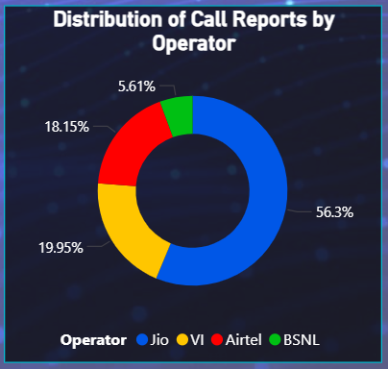
This donut chart shows the contribution of major telecom operators—Jio, Airtel, VI, and BSNL—to total reported call quality issues. It helps compare operator presence and relative impact on network quality, highlighting which operators contribute more significantly to reported issues.

4. Call Quality by Network Technology (2G, 3G, 4G)
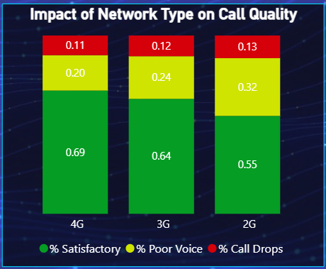
This visualization compares call quality metrics across different network technologies. It clearly shows that older technologies such as 2G experience higher call drop rates and poorer voice quality, while 4G networks demonstrate better performance and higher customer satisfaction. This visual supports the conclusion that technology upgrades play a key role in improving call quality.
5. User Environment Impact on Call Quality
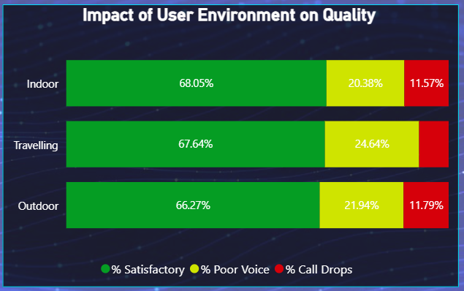
This chart analyzes call quality based on user environment—indoor, outdoor, and travelling. The visualization indicates that calls made while travelling have the highest call drop rates, followed by outdoor environments, while indoor calls generally perform better. This highlights the influence of mobility and signal stability on call quality.
6. Time Trend Analysis of Call Quality
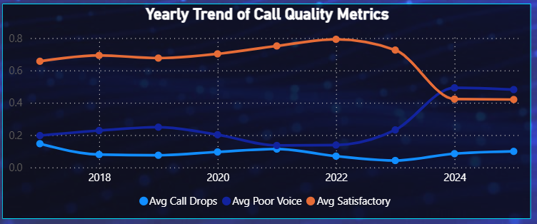The line chart illustrates year-wise trends in call drop rates and customer satisfaction from 2017 to 2024. The trend shows a gradual improvement in call quality over time, particularly after the expansion of 4G networks. However, fluctuations in certain years indicate periods of network stress or uneven improvements.
7. Operator-wise Call Drop Trends
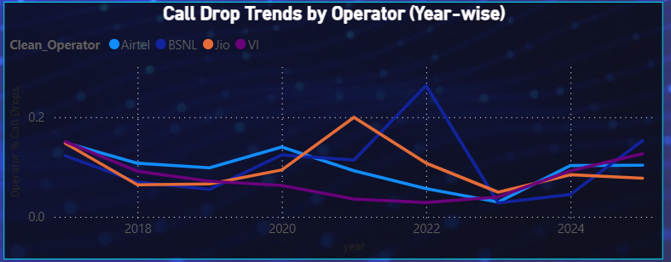This visualization compares call drop trends among major telecom operators over time. It helps identify which operators have shown consistent improvement and which have experienced irregular performance. The chart enables direct comparison of operator reliability across different years.

8. Worst Network Quality Leaderboard
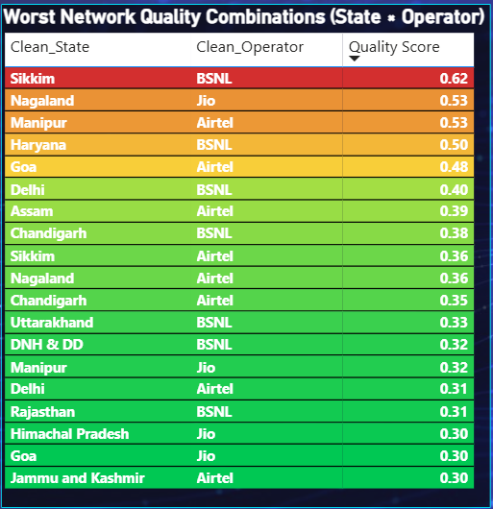
The leaderboard table highlights the worst-performing combinations of state, operator, and network conditions using a composite quality score. This visual helps identify specific problem hotspots rather than generalized nationwide issues, enabling focused analysis and targeted recommendations.
9. Interactive Slicers
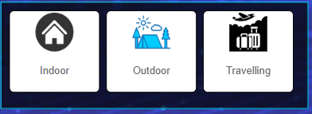
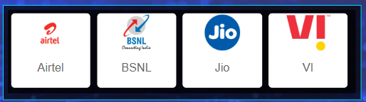
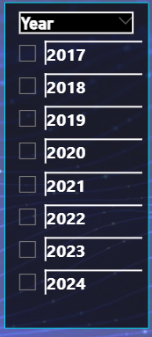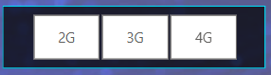
Interactive slicers allow users to filter the dashboard dynamically by year, operator, network type, and user environment. These controls enhance exploratory analysis and enable customized views of the data without modifying the underlying dataset.

DATA ANALYSIS & INSIGHTS

The geographical analysis shows that call quality issues are unevenly distributed across India. Certain states consistently report higher call drop rates and poor voice quality, indicating regional infrastructure and coverage challenges.

The time trend analysis reveals a gradual improvement in overall call quality over the years. Call drops rates generally decrease while customer satisfaction improves, especially after the expansion of 4G networks. However, temporary spikes in some years indicate periods of network congestion or transition.

Analysis of network technologies highlights that 2G networks perform the worst in terms of call drops and poor voice quality. 3G networks show moderate performance, while 4G networks consistently deliver better voice quality and higher satisfaction levels.

The technology mix analysis indicates a steady shift from older technologies (2G and 3G) toward 4G over time, reflecting modernization and increased investment in advanced network infrastructure.

The user environment analysis shows that call quality is significantly affected by surroundings. Calls made while travelling experience the highest call drop rates, followed by outdoor environments, whereas indoor calls generally show better performance.

The operator-wise analysis reveals noticeable differences in telecom service quality among operators. Some operators demonstrate consistent improvement over time, while others show fluctuating performance across states and network types.

The operator trend analysis indicates that poor network performance is often localized to specific regions rather than being uniform across the country.

The worst quality leaderboard identifies specific state–operator combinations that contribute most to poor call quality, highlighting focused problem areas instead of nationwide issues.

Overall, the analysis confirms that telecom call quality in India is influenced by a combination of network technology, geographical location, user environment, and operator performance.

OBSERVATIONS & DISCUSSIONS

The analysis of telecom call quality data reveals noticeable variations in network performance across different regions of India. Certain states consistently experience higher call drop rates and poorer voice quality, indicating regional disparities in telecom infrastructure and coverage. These differences suggest that network performance challenges are often localized and influenced by geographical and infrastructural factors rather than being uniformly distributed nationwide.

A clear trend observed over time is the gradual improvement in overall call quality. Call drop rates tend to decrease while customer satisfaction shows an upward trend, particularly in recent years. This improvement aligns with the increased deployment and adoption of advanced network technologies, especially 4G. However, the presence of temporary spikes in call drop rates during specific periods indicates that network congestion and transitional challenges still exist.

Network technology plays a crucial role in determining call quality. The analysis shows that older technologies such as 2G are associated with higher call drop rates and poorer voice clarity. In contrast, 4G networks consistently provide more stable and satisfactory call experiences. The shift in technology usage over time further supports this observation, with a steady decline in 2G and 3G usage and increased reliance on 4G networks.

User environment is another significant factor influencing call quality. Calls made while travelling experience the highest call drop rates due to frequent handovers between network cells. Outdoor environments also show higher instability compared to indoor settings, where call quality is relatively better. This highlights the impact of mobility and signal consistency on voice communication.

Operator-wise analysis indicates varying levels of performance among telecom service providers. While some operators demonstrate consistent improvement across multiple regions, others show fluctuating performance depending on the state and network technology used. The findings suggest that poor call quality is often concentrated in specific state–operator combinations, emphasizing the need for targeted network optimization rather than broad, uniform strategies.

Overall, the observations and discussions highlight that telecom call quality in India is influenced by a combination of technological advancements, geographical factors, user behavior, and operator-specific strategies. These insights underline the importance of continuous network upgrades, regional performance monitoring, and data-driven decision-making to enhance customer experience and service reliability.

CONCLUSION

This project successfully analyzed telecom voice call quality across India using interactive data visualization techniques. By leveraging open government data and transforming it into meaningful performance metrics, the study provided valuable insights into call drops, poor voice quality, and customer satisfaction across different regions, operators, network technologies, and user environments.
The analysis revealed that telecom call quality in India has generally improved over time, particularly with the increased adoption of advanced network technologies such as 4G. However, the findings also highlight persistent challenges, including regional disparities, operator-specific performance variations, and higher call drop rates in certain environments such as travelling. These issues indicate that despite overall progress, targeted improvements are still required to ensure consistent service quality nationwide.
The dashboard-based approach proved effective in simplifying complex datasets and enabling dynamic exploration of trends and patterns. Interactive visuals such as maps, trend lines, and comparative charts allowed for deeper understanding and facilitated data-driven insights. The inclusion of slicers further enhanced usability by enabling customized analysis based on year, operator, network type, and user environment.
Overall, this project demonstrates the importance of data analytics and visualization in evaluating telecom network performance and customer experience. The insights generated from this analysis can support informed decision-making for network optimization, infrastructure planning, and service quality improvement. The project also highlights the practical application of Power BI and analytical techniques in solving real-world problems within the telecommunications domain.
FUTURE SCOPE
While this project provides a comprehensive analysis of telecom call quality across India, there are several opportunities for further enhancement and expansion in future work. One possible extension is the inclusion of 5G network data, which would allow analysis of next-generation network performance and comparison with existing technologies such as 4G.
The scope of the analysis can also be expanded by incorporating real-time or near real-time data, enabling continuous monitoring of call quality and faster identification of emerging network issues. This would make the dashboard more useful for operational decision-making and proactive network management.
Future studies could integrate additional performance indicators such as data speed, latency, signal strength, and customer complaint records to provide a more holistic assessment of telecom service quality. Combining voice quality metrics with data service metrics would offer deeper insights into overall customer experience.
Another potential enhancement is the application of predictive analytics and machine learning models to forecast call drop trends, identify high-risk regions, and anticipate network failures. Predictive insights could help telecom operators take preventive measures rather than reactive actions.
The dashboard can also be extended to support district-level or city-level analysis, provided more granular data is available. This would allow more precise identification of local problem areas and support targeted infrastructure planning.
Finally, the dashboard can be enhanced with automated reporting and alert mechanisms, where stakeholders are notified when call quality metrics cross predefined thresholds. Such features would increase the practical applicability of the dashboard in real-world telecom monitoring scenarios.
Overall, the future scope of this project lies in expanding data coverage, improving analytical depth, and integrating advanced analytics techniques to support smarter and more proactive telecom network management.

REFERENCES

- Government of India. Voice Call Quality – Customer Experience (Till Last Month).
Open Government Data Platform (data.gov.in).
Available at: https://www.data.gov.in/resource/voice-call-quality-customer- experience-till-last-month
- Microsoft Corporation. Power BI Documentation.
Available at: https://learn.microsoft.com/power-bi/
- Telecom Regulatory Authority of India (TRAI). Telecommunication Services Performance Indicators.
Available at: https://www.trai.gov.in
- Lovely Professional University - Data Science Curriculum

IMPORTANT LINKS
1)Link to Dataset: Link for Dataset
2)Link to GitHub Repository: Link to GitHub
3)Link to LinkedIn Post: Link to LinkedIn
4)Link of google drive: Link to Google Drive

